SCD Lab 11
Laiba Fatima 22k-5195
Task1
package com.example.lab11;
import org.springframework.stereotype.Service;
import java.time.LocalTime;
@Service
public class GreetingService {
public String getGreetingMessage(String name, String language) {
String greeting;
// Determine greeting based on time of day
LocalTime currentTime = LocalTime.now();
if (currentTime.isBefore(LocalTime.NOON)) {
greeting = "Good morning";
} else if (currentTime.isBefore(LocalTime.of(17, 0))) {
greeting = "Good afternoon";
} else {
greeting = "Good evening";
}
// Customize greeting based on language
switch (language.toLowerCase()) {
case "french":
greeting = greeting.replace("Good", "Bonjour");
break;
case "spanish":
greeting = greeting.replace("Good", "Buenos");
break;
case "english":
// Default to English
break;
default:
throw new UnsupportedOperationException("Language not supported: " + language);
}
return String.format("%s, %s!", greeting, name);
}
}

package com.example.lab11;
import org.springframework.beans.factory.annotation.Autowired;
import org.springframework.http.HttpStatus;
import org.springframework.http.ResponseEntity;
import org.springframework.web.bind.annotation.*;
@RestController
@RequestMapping("/task1")
public class GreetingController {
private final GreetingService greetingService;
@Autowired
public GreetingController(GreetingService greetingService) {
this.greetingService = greetingService;
}
@GetMapping("/{name}")
public String greetUser(@PathVariable String name, @RequestParam(defaultValue = "english") String language) {
return greetingService.getGreetingMessage(name, language);
}
}

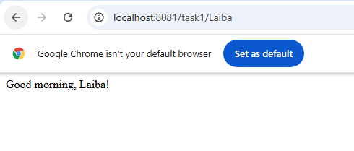
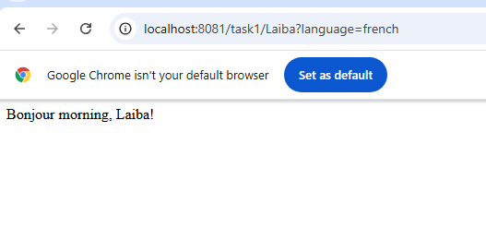
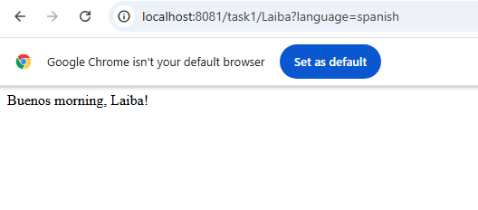
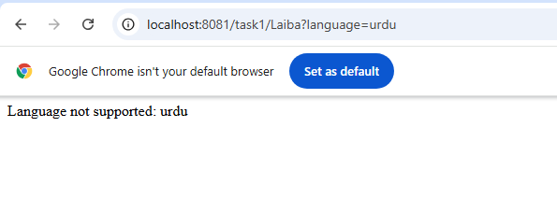
Task 2

<!DOCTYPE html>
<html>
<head>
<title>Spring Boot Login and Registration Form</title>
</head>
<body>
<h2>Login or Register</h2>
<!-- Login Form -->
<form action="/task2login" method="post">
<label for="username">Username (Login):</label>
<input type="text" id="username" name="username" required>
<br>
<label for="password">Password:</label>
<input type="password" id="password" name="password" required>
<br>
<button type="submit">Login</button>
</form>
<br>
<!-- Registration Form -->
<form action="/task2register" method="post">
<label for="regUsername">Username (Register):</label>
<input type="text" id="regUsername" name="username" required>
<br>
<label for="regPassword">Password:</label>
<input type="password" id="regPassword" name="password" required>
<br>
<button type="submit">Register</button>
</form>
</body>
</html>

package com.example.lab11;
import org.springframework.stereotype.Controller;
import org.springframework.web.bind.annotation.*;
import java.util.ArrayList;
import java.util.List;
@Controller
public class UserController {
// Predefined user list for checking existing usernames
private List<String> registeredUsernames = new ArrayList<>(List.of("user1", "user2"));
// GET Mapping to display the form (optional if using a static HTML page)
@GetMapping("/task2")
public String showForm() {
return "task2"; // returns form.html in templates folder
}
// Registration endpoint
@PostMapping("/task2register")
@ResponseBody
public String register(@RequestParam String username, @RequestParam String password) {
// Check if username already exists
if (registeredUsernames.contains(username)) {
return "Username is already taken. Please choose a different one.";
} else {
registeredUsernames.add(username);
return "Registration successful!";
}
}
// Login endpoint
@PostMapping("/task2login")
@ResponseBody
public String login(@RequestParam String username, @RequestParam String password) {
// Simple validation (for demonstration, usually you would verify password as well)
if (registeredUsernames.contains(username)) {
return "Login successful!";
} else {
return "Login failed. Username not found.";
}
}
}

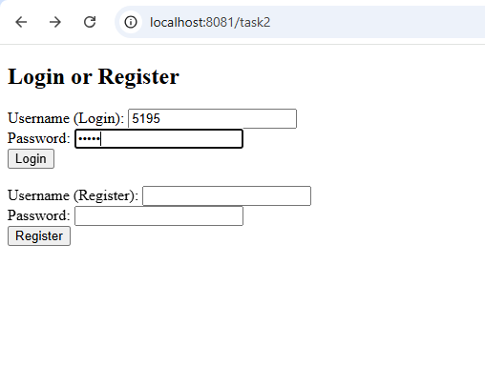
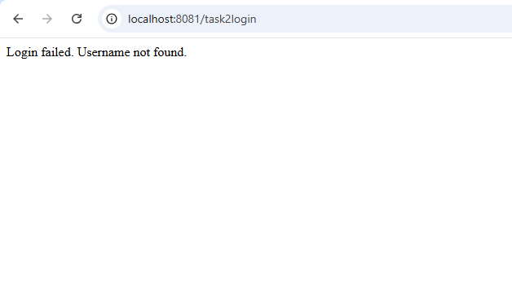
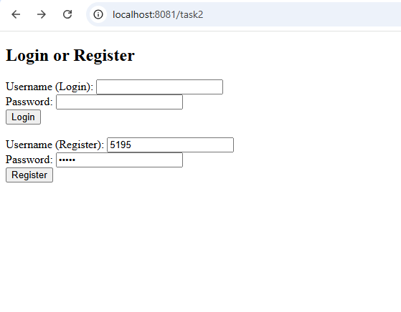
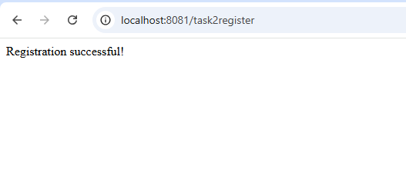
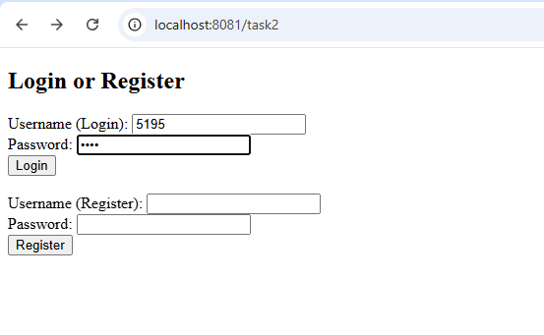

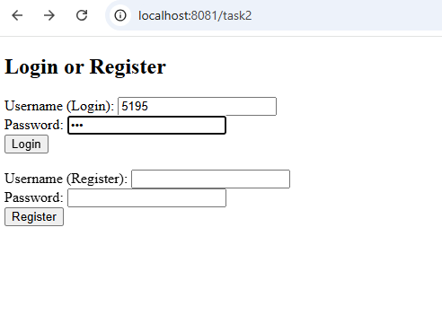
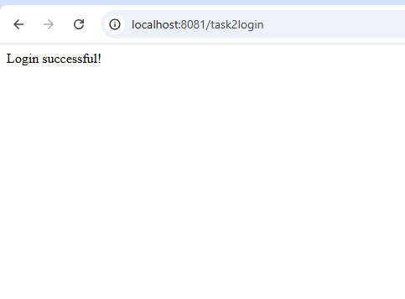
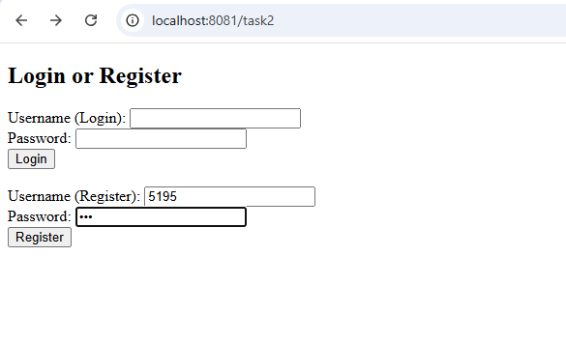
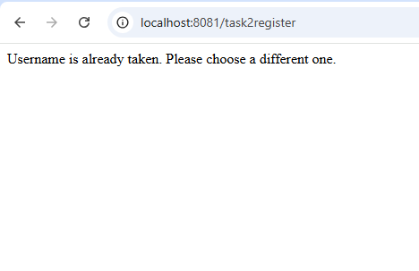
Task 3
package com.example.demo;

import org.springframework.http.HttpStatus;
import org.springframework.http.ResponseEntity;
import org.springframework.web.bind.annotation.*;

import java.util.ArrayList;
import java.util.List;
import java.util.Optional;

@RestController
public class ItemController {

private List<Item> items = new ArrayList<>();
private int currentId = 1;

@PostMapping("/items")
public ResponseEntity<String> addItem(@RequestParam String name, @RequestParam double price) {
Item newItem = new Item(currentId++, name, price);
items.add(newItem);
return ResponseEntity.status(HttpStatus.CREATED).body("Item added successfully with ID " + newItem.getId());
}

@GetMapping("/items")
public ResponseEntity<?> getItem(@RequestParam(required = false) Integer id) {
if (id == null) {
return ResponseEntity.ok(items);
} else {
Optional<Item> item = items.stream().filter(i -> i.getId() == id).findFirst();
if (item.isPresent()) {
return ResponseEntity.ok(item.get());
} else {
return ResponseEntity.status(HttpStatus.NOT_FOUND).body("Item not found");
}
}
}

@PostMapping("/items/update")
public ResponseEntity<String> updateItem(@RequestParam int id, @RequestParam String name, @RequestParam double price) {
Optional<Item> itemOpt = items.stream().filter(i -> i.getId() == id).findFirst();
if (itemOpt.isPresent()) {
Item item = itemOpt.get();
item.setName(name);
item.setPrice(price);
return ResponseEntity.ok("Item updated successfully");
} else {
return ResponseEntity.status(HttpStatus.NOT_FOUND).body("Item not found");
}
}

@PostMapping("/items/delete")
public ResponseEntity<String> deleteItem(@RequestParam int id) {
Optional<Item> itemOpt = items.stream().filter(i -> i.getId() == id).findFirst();
if (itemOpt.isPresent()) {
items.remove(itemOpt.get());
return ResponseEntity.ok("Item deleted successfully");
} else {
return ResponseEntity.status(HttpStatus.NOT_FOUND).body("Item not found");
}
}
}
class Item {
private int id;
private String name;
private double price;

public Item(int id, String name, double price) {
this.id = id;
this.name = name;
this.price = price;
}

public int getId() {
return id;
}

public void setId(int id) {
this.id = id;
}

public String getName() {
return name;
}

public void setName(String name) {
this.name = name;
}

public double getPrice() {
return price;
}

public void setPrice(double price) {
this.price = price;
}
}

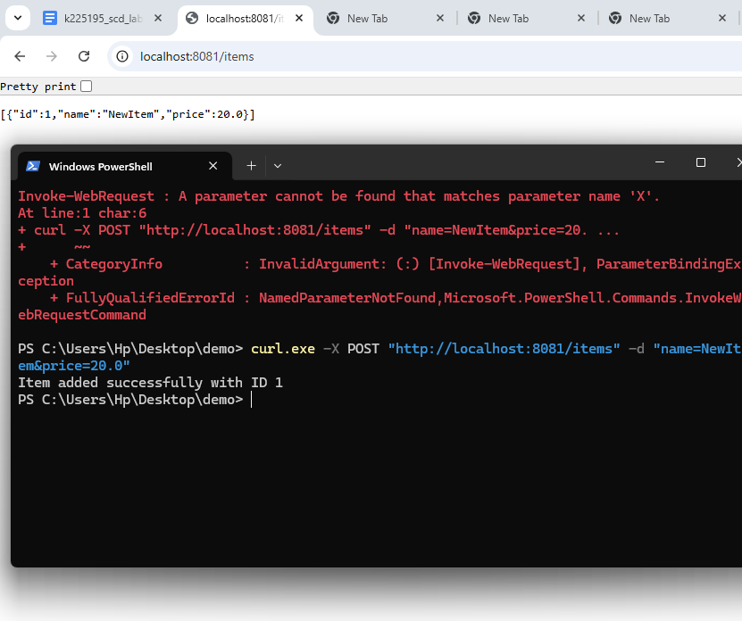
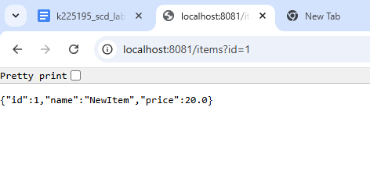
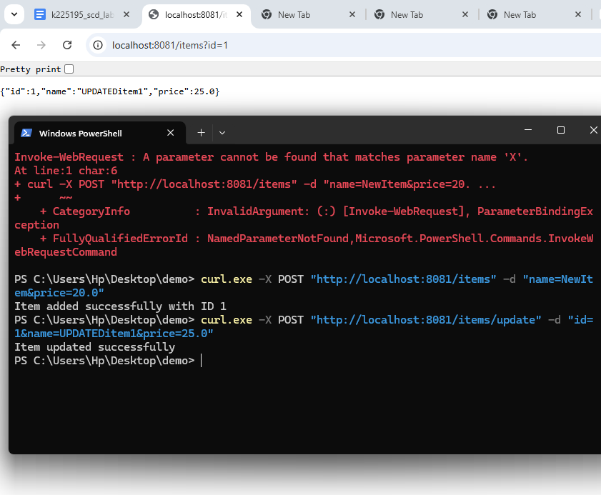
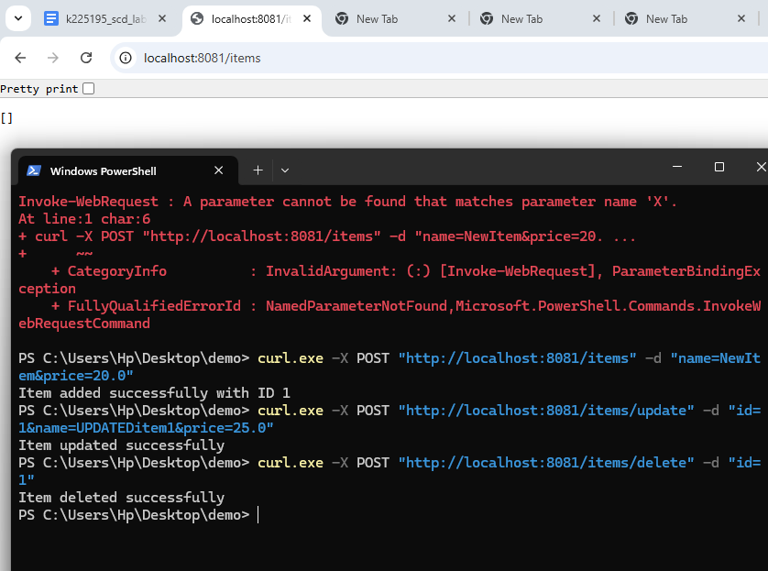
Task 4
package com.example.demo;

import org.springframework.web.bind.annotation.PathVariable;
import org.springframework.web.bind.annotation.RequestParam;
import org.springframework.web.bind.annotation.GetMapping;
import org.springframework.web.bind.annotation.PathVariable;
import org.springframework.web.bind.annotation.RequestParam;
import org.springframework.web.bind.annotation.RestController;
@RestController
public class ReportController {

@GetMapping("/report/{year}/{month}")
public String getReport(
@PathVariable int year,
@PathVariable String month,
@RequestParam(value = "type", required = false, defaultValue = "summary") String type) {

String reportType = type.equalsIgnoreCase("detailed") ? "detailed" : "summary";

return String.format("Displaying a %s report for %s %d.", reportType, month, year);
}
}

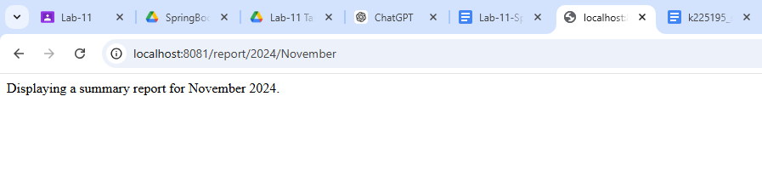
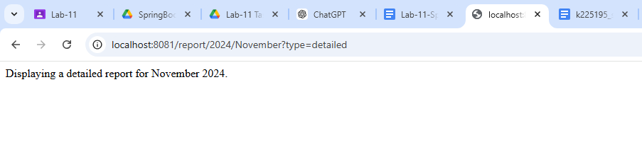
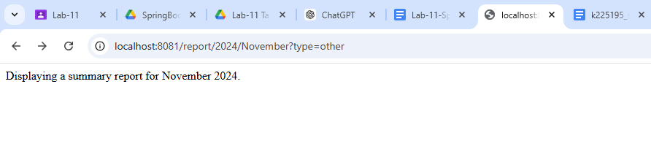
Task 5
package com.example.demo;

import org.springframework.stereotype.Controller;
import org.springframework.ui.Model;
import org.springframework.web.bind.annotation.GetMapping;
import org.springframework.web.bind.annotation.RequestParam;

import java.util.ArrayList;
import java.util.List;
import java.util.stream.Collectors;

@Controller
public class ProductController {

private List<Product> getProducts() {
List<Product> products = new ArrayList<>();
products.add(new Product("Laptop", "Electronics", 1200.00));
products.add(new Product("Smartphone", "Electronics", 800.00));
products.add(new Product("T-shirt", "Clothing", 20.00));
products.add(new Product("Jeans", "Clothing", 40.00));
products.add(new Product("Blender", "Home Appliances", 60.00));
return products;
}

@GetMapping("/products")
public String showProducts(@RequestParam(value = "category", required = false) String category, Model model) {
List<Product> products = getProducts();

if (category != null && !category.isEmpty()) {
products = products.stream()
.filter(product -> product.getCategory().equalsIgnoreCase(category))
.collect(Collectors.toList());
}

model.addAttribute("products", products);
model.addAttribute("selectedCategory", category);

return "products";
}
}
class Product {
private String name;
private String category;
private double price;

public Product(String name, String category, double price) {
this.name = name;
this.category = category;
this.price = price;
}

public String getName() {
return name;
}

public void setName(String name) {
this.name = name;
}

public String getCategory() {
return category;
}

public void setCategory(String category) {
this.category = category;
}

public double getPrice() {
return price;
}

public void setPrice(double price) {
this.price = price;
}
}

<!DOCTYPE html>
<html xmlns:th="http://www.thymeleaf.org">
<head>
<meta charset="UTF-8">
<title>Product List</title>
</head>
<body>
<h1>Product List</h1>

<!-- Category filter form -->
<form action="#" th:action="@{/products}" method="get">
<label for="category">Filter by Category:</label>
<select name="category" id="category">
<option value="" th:selected="${selectedCategory == null}">All</option>
<option value="Electronics" th:selected="${selectedCategory == 'Electronics'}">Electronics</option>
<option value="Clothing" th:selected="${selectedCategory == 'Clothing'}">Clothing</option>
<option value="Home Appliances" th:selected="${selectedCategory == 'Home Appliances'}">Home Appliances</option>
</select>
<button type="submit">Filter</button>
</form>

<!-- Display product list -->
<table>
<thead>
<tr>
<th>Product Name</th>
<th>Category</th>
<th>Price</th>
</tr>
</thead>
<tbody>
<tr th:each="product : ${products}">
<td th:text="${product.name}"></td>
<td th:text="${product.category}"></td>
<td th:text="${product.price}"></td>
</tr>
</tbody>
</table>
</body>
</html>

